Where Should I Live?

This investigation takes students through the inquiry process to discover how transportation is a significant factor in helping people in cities decide where they will live. It uses the RBC & Pembina Institute Location Matters report and online interactive tool.

Inquiry Stage One: Initiate and Plan

Imagine that you are 25 years old and living in the Greater Toronto Area. This is not a prediction just an exercise in imagination and deduction. Think of yourself at age 25. Create a short profile of yourself:
- What is your job? Where is it located?
- What cultural interests do you have?
- What sports or exercise do you take part in?
- What kinds of entertainment interest you?

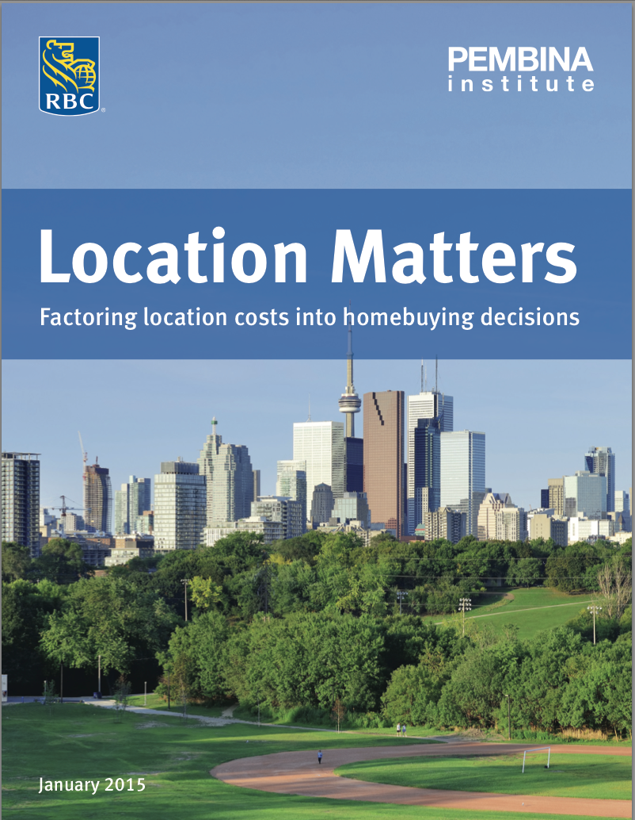

Now locate the online Location Matters report and interactive tool. The report to download and the online tool can both be found at: http://www.pembina.org/pub/location-matters. These are what you will use to think about where you might be living at age 25. Examining this report carefully will help you decide where in the approximately 7,000 km² of the GTA you might choose to locate.

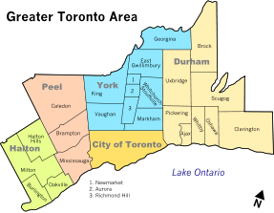

Inquiry Stage Two: Perform (Investigate) and Record

Now that you have the materials for your inquiry, you can start your investigation. Begin by looking at the four profiles in the report (p.5). They present a general overview for each person and their decision to move. Compare thoughts with another student to ensure you understand the scenarios.

Browse through the different detailed scenarios (pp.5, 6 12 18 and 25) and look at the information that is included. Watch for the various characteristics the different people looking for? Ask your teacher or another student if you are unsure of any of the information.
- What is the difference between detached and semi-detached?
- Why would someone want a finished basement?
- Ask your parents/guardians to calculate their total commuting time per month.
- Which profile is closest to your present family?
- Is there another profile that matches someone you know?
- Which one matches the 25 year old you that you imagined at the start of the inquiry?

Next, familiarize yourself with online interactive tool. It is located here: (https://www.rbcadvicecentre.com/pembina-location-matters/). It is set up to show the different options each person has for moving to the home they desire. Become familiar with how this tool works before going further.

Check your understanding with the following questions:
- How many moving options does each person have?
- Why is there a box included for each option titled “What they wanted”?
- What is meant by the Less ‘walkable’ … More ‘walkable’ continuum line?

Commuting is costly for all families. Choose one of the people profiled here. For each of the five options they are considering, calculate the percentage increase in their housing cost if transportation costs are taken into account. As a class fill out the following chart by combining other students’ calculations:

Person | Option | % housing cost increases when transportation costs added
Derek | A
Derek | B
Derek | C
Derek | D
Derek | E
Priya | A
 | B
 | C
 | D
 | E
Julie | A
 | B
 | C
 | D
 | E
Dominic | A
 | B
 | C
 | D
 | E

As a class, discuss what conclusions you can draw from this completed chart.

You need to also discover how the report came up with the different numbers in the charts. For a general overview, look at page 4. Full details of the calculations are given in the Appendix which begins on p.31.

Investigate the effects that this report could have. Divide into the following five groups and think about the impact of the information in the report and online interactive tool.
- House prices
- Demand for houses
- Real estate advertisements
- Pollution levels
- Transit policies
Report back to the class as a whole.

Inquiry Stage Three: Analyze and Interpret

In this step of the inquiry, you need to think about how the information you have discovered impacts the original question of where you will be living when you are 25 years old. The Location Matters report demonstrated how four people were looking at housing costs, commuting time and neighbourhood walkability and livability. The report helps explain the cost of commuting in terms of money and time. As you think again about where you might be living when you are 25, work with a partner to answer the following questions:
- Ask a parent or family member and another adult you know whether they took into account commuting costs when they chose where to live
- How could commuting be considered a quality of life issue?
- What is your present home’s walkability score? (use this website to calculate it: https://www.walkscore.com )

The Location Matters report does a very complete job of calculating the impact of commuting on the decision to choose where to live, but you might have other ideas for factors that could be included. Form small groups in your class to brainstorm what lese could be added as considerations. Think of the following prompts to help you generate a list.
- Are there other monetary costs that the report has not been able to take into account (see Appendix pp. 31-6 for details on their calculations)
- Are there other non-monetary factors you would take into account that don’t fit into the categories of housing costs, commuting time and neighbourhood walkability and livability
- Imagine that you had a huge budget to make an online calculator to help people plug in their individual data for different housing choices. What data is there already? What additional data would you need to create an online calculator?

There are wider impacts of this report that need to be examined. One group that could be affected is real estate agents. If possible, interview a real estate agent about their reaction to the report.
- Is this information valuable to real estate agents?
- How could they make use of it?
- How might they need to adjust their business as a result?

Politicians and political parties are also impacted by studies on transportation and housing. In a recent speech Premier Kathleen Wynne praised the work on this report. [link to speech]:
- Why did the Premier praise the report?
- Why are transportation costs for families of such interest to the Premier of a province?
- Which Ministers of her government would be interested in the findings of this report?
- What are three policies that could be created that would change the situation for the four people profiled in the report?

With all this information in mind, what do you conclude is the most desirable place for you to live when you are 25 years old? Obviously costs will change and policies and other realities might make the GTA and commuting very different. But thinking of the GTA as it is now, what would be your choice of where to live?

Inquiry Stage Four: Communicate

The final step in our inquiry is to communicate our findings. The first step is to communicate the importance of the report to others. Choose one of the following people to send a message to:

a. Real estate agent
→ How does the real estate industry need to change as a result of the Location Matters report?

b. A parent
→ What is the best place for our family to live, based upon the findings of the Location Matters report ?

c. An MPP (member of Provincial Parliament)
→ Be aware of the importance of the Location Matters report and its impact on your riding.

The second step is to share as a class the results of our central question: Where should I live? Place a big map of the GTA (Greater Toronto Area) – such as a road map – on the wall of the classroom and have everyone put a push pin or a sticky dot on the map on the location that they have concluded is the best choice for them to be living when they are 25 years old.

Ask four or five students to explain why they chose the locations that they did. Conclude with a class discussion about the general conclusions they have made about the report and its importance. You are invited to post your thoughts – or a photo of your map, in the COOL 2.0 database.

Tags:

location matters, RBC, Pembina, housing, transportation, interactive, commuting, calculate, inquiry, inquiry method

