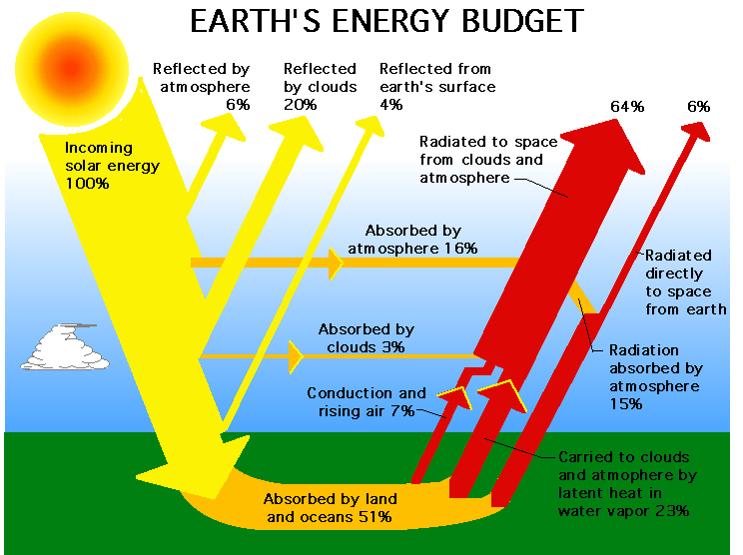

What is radiation?

Why is having an atmosphere important to the Earth and to the life on it?

What is the Natural Greenhouse Effect?

What is the Anthropomorphic Greenhouse Effect? What is it doing to the Earth’s temperature?

