Demonstration of Heat Transfer through Radiation

Name:

Materials:
black mitt 2 thermometers (optional)
white mitt
heat lamp

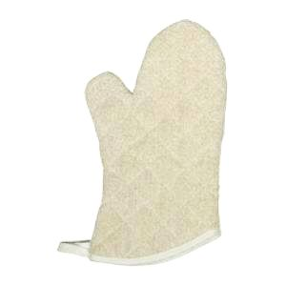
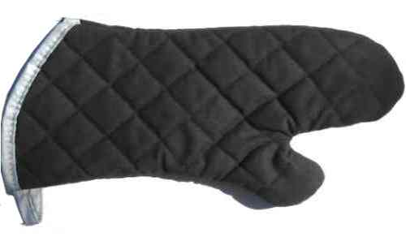
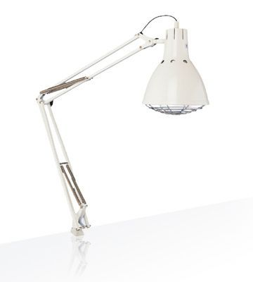
Experimental Set-up:

- Put each hand in a different coloured mitt.
- Hold your hands an equal distance away from the heat lamp – about 0.25m. (Your teacher will help you with this.)
- Pay attention to how your hands feel after a couple of minutes.
- Optional: Put a thermometer in each mitt, then put mitts an equal distance away from the heat lamp. Check to make sure that the thermometers are in the middle of each mitt with the bulb about where the 1st knuckle of your pointer finger would be. Record the temperature after 2 min,

Observations:
 | Observations | Explanation
Black mitt

White mitt

