The Layers of the Earth’s Atmosphere
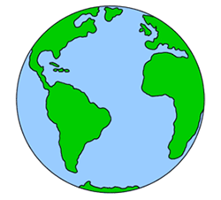
Layers: Write the name of the layers in the box.
Sketch: The temperature profile of the
atmosphere in the middle of the diagram.

Distance (km)

Everyday things for this layer

