Time & Cycles - Dendrochronology
Modified with permission from Global Change: Time and Cycles, Department of the Interior, U.S. Geological Survey, Reston, VA, USA.
Background
Trees contain some of nature's most accurate evidence of the recent past. Their growth layers, appearing as rings in the cross section of the tree trunk, record evidence of floods, droughts, insect attacks, lightning strikes, and even earthquakes.
Each year, a tree adds to its girth. In environments with distinct seasons the new growth often forms a visibly distinct “tree ring”. Tree growth depends upon local conditions such as water availability and temperature. Because the amount of water available to the tree varies from year to year, scientists can often use tree-ring patterns to reconstruct regional patterns of drought and climatic change. This field of study, known as dendrochronology, was begun in the early 1900s by an American astronomer named Andrew Ellicott Douglass.
A tree ring consists of two layers:
- A light colored layer grows in the spring
- A dark colored layer in late summer
During wet, cool years, most trees grow more than during hot, dry years and the rings are wider. Drought or a severe winter can cause narrower rings. If the rings are a consistent width throughout the tree, the climate was the same year after year. By counting and carefully measuring the rings of a tree, we can pretty accurately determine the age and evaluate the trees past health and growing conditions of each year.
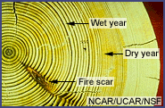
Modern dendrochronologists seldom cut down a tree to analyze its rings. Instead, core samples are extracted using a borer that's screwed into the tree and pulled out, bringing with it a straw-size sample of wood about 4 millimeters in diameter. The hole in the tree is then sealed to prevent disease.
Computer analysis and other methods have allowed scientists to better understand certain large-scale climatic changes that have occurred in past centuries. These methods also make highly localized analyses possible. For example, archaeologists use tree rings to date timber from log cabins and Native American pueblos by matching the rings from the cut timbers of homes to rings in very old trees nearby. Matching these patterns can show the year a tree was cut, thus revealing the age of a dwelling.
To investigate the extent, speed, and effects of historical climate changes locally and globally, scientists rely on data collected from tree rings, ice cores, pollen trapped in sediments, coral reefs and the fossil record. Computers are used to detect possible patterns and cycles from these sources. In dendrochronology, large databases allow scientists to compare the ring records of many trees, construct maps of former regional climates, and reveal when, where, and how quickly the climates changed. These historical records are extremely valuable as we struggle to understand the extent and nature of any possible future climate change.
Materials for Each Group of Four Students
- A set of paper strips pre-marked with ring patterns..
- Transparent tape
- A worksheet
Procedure
The graphic below shows how the Sample 1 and Sample 2 strips can be aligned.
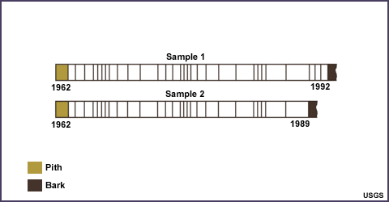
The pith (central layer) and bark are not counted in determining the age of a sample. The youngest ring is closest to the bark and the oldest ring is closest to the pith.
- Imagine you have core samples from 4 trees:
  - Sample 1: From a living tree from the Pinetown Forest, July 1993
  - Sample 2: From a tree from the Pinetown Christmas Tree Farm
  - Sample 3: From a log found near the main trail in Pinetown Forest
  - Sample 4: From a barn beam removed from Pinetown Hollow

- Determine the age of each tree (how many years it had been growing) by counting the rings.
- Look for patterns in the rings. Once you have discovered a ring pattern, line up all the samples. (Note that although the patterns in this exercise match well, actual ring patterns vary among tree species.)
- Knowing that Sample 1 was cut in 1993, match the patterns of the other samples and determine when the other trees were cut or cored and when they began to grow. Record this information in the chart below. Give your table a name and write a brief caption as to what it is about.
Observations;

Sample | Age of Tree | Year Cut or Cored | Year Growth Began
1
2
3
4
Questions
- Which tree ring represents Canada’s Centennial year?
- What kind of growing season (good or bad) existed that year in Pinetown? How can you tell?

- If poor tree growth around Pinetown was mainly caused by drought, which years were probably drought years? How can you tell?

- Did Pinetown have more years of drought or plentiful rainfall?

Answer Key:
Sample | Age of Tree | Year Cut or Cored | Year Growth Began
1 | 31 years | 1993 | 1962
2 | 28 years | 1990 | 1962
3 | 39 years | 1988 | 1949
4 | 28 years | 1970 | 1942

