Using Ice Cores to Collect Evidence of Past Climates
NAME:

Introduction:
Glaciers hold many clues about climate and atmospheric conditions throughout Earth’s history. Within glaciers, there are sequential layers of ice deposition that
contain characteristics of the atmosphere at the time they formed. Within an ice core, it is possible to infer differences in temperature, precipitation, atmospheric composition, volcanic activity, and wind patterns using a typical coring strategy (Palais et al. 1988; Zielinski et al. 1994; Fiedel, Southon, and Brown 1995; Riebeek 2005). Scientists drill into ice sheets or glaciers and then label and analyze the ice core for data, which can include oxygen isotopes, layer thickness, the gases in air bubbles, methane levels, chemical composition of dust, and dates of ash layers.
From these measurements we can infer atmospheric conditions and global climate at the time the sample formed. In the first part of this lab, you will analyze
mock ice core samples and focus on three variables: the thickness of the ice, the presence of airborne particles, and the pH value of each section of the sample.

Connecting to the “big picture”
Throughout Earth’s history, there have been extended periods of volcanic activity, which have greatly affected Earth’s climate. Volcanoes emit ash and gases that affect atmospheric conditions, which, in turn, affect climate. In most cases, greatly increased volcanic emissions cause colder global temperatures and acidic precipitation. These geological events are recorded in the layers of ice found in glaciers and correlate directly with climate conditions inferred from tree-ring growth data (like that which you analyzed in your previous lab) from the same time period.
We are well aware of the critical role that air pollution, especially CO₂ emissions, plays in global climate change; industrial pollution can clearly be seen within the ice core record.

Purpose:
In this lab, you will investigate the relationship between airborne particles in a mock glacial ice core, the thickness of layers within the core sample, and pH values. In the analysis of these ice cores, you will make predictions and draw conclusions similar to scientists’ findings. You will then interpret your findings in light of current climate change research. Following the wet lab, you will use the internet to examine the data from a real ice core.

Materials: (per pair of students)
ruler razor blade
paper towel (to hold ice core) 5 petri dishes
full range pH paper (10 small pieces) 1 eyedropper
3 watch glasses magnifying glass
dissecting microscopes (to be shared…there are only 3)

PART A: Dissecting an Ice Core
Procedure:
- Obtain your ice core (in its test tube) and bring it back to your desk.

- Predict whether your ice core will show any evidence of air pollution (that may indicate climate change) and support it with a reason.
/2
I

- Examine your ice core using a magnifying glass.
  - Count the number of layers that are present
  - Measure each of the layers
  - Note any characteristics of your ice layers in the observation table.
  - Sketch your ice core in the Figure of the test tube in the observations section.

- Using your observations, predict what could have caused the variation in your layers. For this example, assume your ice core represents 4 000 years. Verify your prediction with the teacher before moving to step 5.
Prediction:

/2
I

❑ Teacher verification

- Pay close attention to the teacher demonstration on removing the ice core from the test tube.
Summarize how you remove the ice core.

/2
KU

- In order to prevent your ice core from slipping, hold it firmly with the paper towel.

- Use the razor blade to score all the way around the layers, one by one. Cut about 1-2 mm into the ice core. Then tap it on the desk to separate it.

- Place each of the core samples in different labelled petri dishes.

- Measure the pH of each of the cores by touching the damp surface with the full range pH paper, then comparing the colour it turns to the colour pH range.

Observations:

Table 1: Descriptive characteristics of Ice core

Core Layer | Thickness (cm) | Presence of Particles | pH | Other Observations
A
Lowest layer

/4
I
table
B

C

D

E
Topmost layer

/2
I
diagram
Figure 1: Diagram of Ice Core. The oldest layer (at the bottom) is identified as A.

Analysis:
- What pattern do you notice among pH, thickness and presence/absence of particulate matter?
/1
I

- What does the particulate matter in your ice core represent?
/1
I

- Why are the ice core layers thicker when there is particulate matter in them? (Explain what the climate is like at that time, and what would be happening to increase the thickness of the layers.)

/4
I

- a) What is an additional test you would like to do on your ice core? Why?
/2
I

b) How would you do this test?
/2
I

- If you had a tree core from the same period of time, what pattern would you expect to see in it? Defend your answer.

/2
I

- What are a couple of careers that one can pursue in paleoclimatology?

/2
I

CRITERION | LEVEL 4 | LEVEL 3 | LEVEL 2 | LEVEL 1
Written  Cmmunication  /4 | Scientific terminology is used meticulously and correctly. There are no spelling errors. Answer is concise and on topic. There is a logical flow of information. | Scientific terminology is usually used and is correct. There are few spelling errors. Answer is fairly concise and mostly on topic. The flow of information is fairly logical | Scientific terminology is sometimes used and is not always correct. There are frequent spelling errors. Answer is long and not always on topic. The flow of information is not well organized. | Scientific terminology is seldom used and is often correct. There are abundant spelling errors. Answer is rambling and much of it is off topic. Answer is disjointed and hard to follow
SUBMIT THESE PAGES TO YOUR TEACHER FOR GRADING WHILE YOU DO THE
NEXT PART OF THIS ACTIVITY
/2 /20 /2 /2
KU I A C
PART B: Analysis of Ice Cores from Antarctica and Greenland

Go to http://www.antarctica.ac.uk/images/video/player.php?id=cf71156c
and watch the video clip of an ice core being drilled. This is for information only, and to give you an idea of what happens.

Go to http://www.pbs.org/wgbh/nova/warnings/stories/
  - Read the information present.
  - Open the Ice Core timeline
Sketch the ice core in the space below.
Identify the sections by date and include a key event that was learned from each of the core sections (by the date).

Now go to “The Habitable Planet” website at: http://www.learner.org/channel/courses/envsci/unit/unit_vis.php?unit=12
Select the Ice Core animation.
  - What information can be determined from the layers of an ice core? How is it interpreted?

Select the Polar Ice Core animation.
  - CO₂ and temp
    - For how many years can we gather information from the polar ice cores?

    - What pattern consistently emerges from the polar ice cores?

    - Why is the current concentration of CO₂ such a concern to the man in the video?

The Lake Vostok, Antarctica Ice Cores
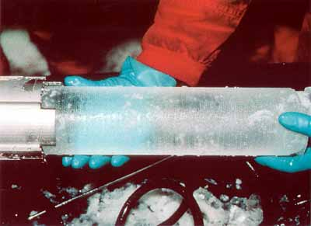
One of the primary results of paleoclimate research over the past decade has been strong evidence for human-influenced (anthropogenic) global warming. Results have been based on ice cores taken from undisturbed ice sheets, such as those in Antarctica. Ice cores provide uninterrupted information on important properties of paleoclimate, including local temperature and precipitation rate, humidity, and wind speed as well as changes in atmospheric composition.
Figure 2 Ice core
http://www.aad.gov.au/asset/images/525_ul-core.jpgaccess e
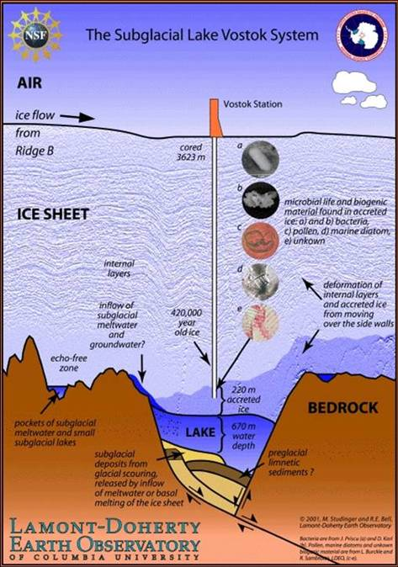
Vostok is the Antarctic research base founded by the Soviet Union in 1957. Even though the US has bragging rights to a research base at the South Pole, the (now) Russian base at Vostok is much more important scientifically. First of all it sits over one of the thickest (>4km) portions of the East Antarctic Ice Sheet. Second, this ice is relatively undisturbed (elsewhere the ice has been subject to substantial flow and/or seasonal conditions that might destroy the ice). Third, under the 4km ice sheet at Vostok lies a lake the size of Lake Ontario that has been cut off from Earth surface conditions for perhaps 15 million years.
The gas age is calculated assuming that the bubbles of gas can only be trapped effectively in layers of older ice (i.e., at a depth well below the surface, where the pores in the ice close, sealing the air). This process is called sintering.
Oxygen and hydrogen isotopes are used to help
determine temperatures at the time the snow fell.
- Now go to the Paleoclimatology page of the National Oceanic and Atmospheric Administration website. At this site, you can access actual ice core data.
Figure 3: The subglacial Lake Vostok Ice layer
http://www.ncdc.noaa.gov/paleo/icecore/antarctica/vostok/vostok_data.html
Open and examine the CO₂ data that Barnola, et al. (1987) collected.
Then, go to the dust data and look at the data posted by Petit, et al (1999)
What comments came to mind as you looked at these?

- The graphs below were generated from similar data. Examine Figures 4 and 5 then answer the questions that follow each.
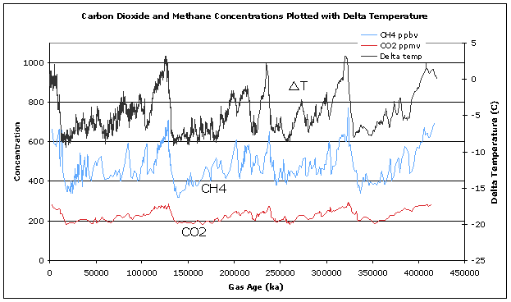

Figure 4: Carbon dioxide and methane concentrations plotted with delta temperature

  - Note the time of the major warming events. Then look at how CO₂ and CH₄ change during the same time. Can you tell which changes first, temperature or greenhouse gas (CO₂, CH₄) composition? (Note the direction of the x-axis.) Briefly explain the pattern you see in the graph with respect to the above question.

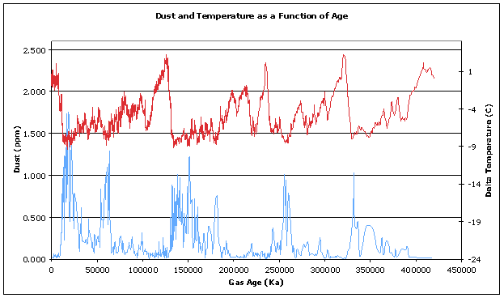

Figure 5: Dust and temperature as a function of age.

  - These graphs do not show recent values. Why were dust concentrations different during the glacial and interglacial periods?

  - Predict how the Industrial Revolution might have affected the global concentration of dust.

- If you had tree cores from the same period of time as the ice core used in the above figures, what would you expect to see in the tree cores?

