Are White Roofs a Solution To Mitigate Climate Change? - Investigation

Background
Albedo is the amount of sun light that is reflected from an object or surface (Nelson 10, 2009). High albedo means that much of the incoming solar radiation to Earth is reflected, for example, by snow and ice. Low albedo means that much of the incoming radiation is absorbed (Pearson, 2009). Recent efforts in southern states have centered around painting roofs white to increase albedo and reduce heat radiating into the atmosphere (CBC, 2007). In this lab, the impact of white roofs on global warming will be evaluated.

Question: Do white roofs help fight climate change?

Focus Question: Will white roofs radiate less heat than black roofs, and therefore reduce global warming?

Apparatus:

Materials:

Variables:
Independent:
Dependent:
Controlled variables:

Procedure

Observations

Results

Conclusion

Evaluation
Teacher Notes:
This can be performed as an independent investigation by students or as a collaborative class experiment.
Begin with a refresher on albedo.
Search for video on painting roofs white to put this investigation into context (home owners in southern states do this).
Have students critique a lab design by identifying uncontrolled variables from the picture.

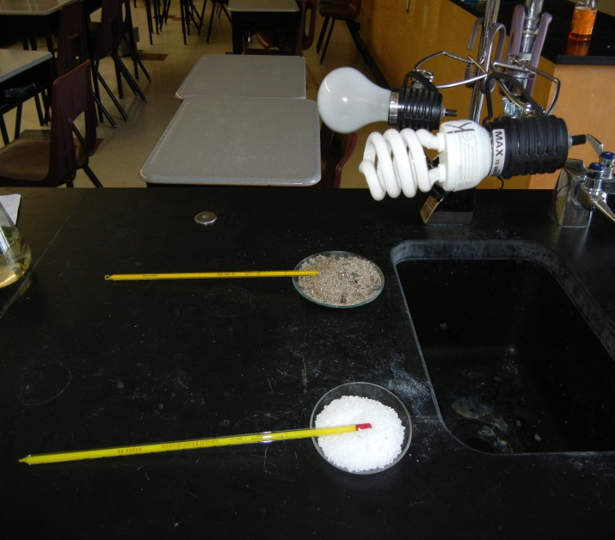
-comparing two different substances (sand, salt)
-these substances are not roofing materials
-more sand
-thermometer is buried in the sand and sitting on top of salt
-two different light/heat sources
-varied distance of light from surface

Allow students to problem solve how they will set up this experiment.
Suggested materials include shingles, paint, thermometers, lights, sun.
Lead students to consider position of thermometer (on surface or above).
Post lab discussion could include if this is a viable option for home owners in Canada (dark roofs are beneficial in winter to melt snow).

