STEP 2: Create your DeforestACTION Plan!

Now that you have created your SMART goals, it is time to create a deforestACTION plan! The purpose of an action plan is to create connection between the SMART goals you have created, and the steps that need to take to achieve your SMART goals.

In your project team:

- Think about the steps you will need to take in order to make your SMART goal a reality!
- Think about any challenges that may arise – what will you do you make sure you can overcome them? Being prepared for challenges is a great way to ensure that your plan will be a success!

The example below highlights an action plan of a student-run composting program to highlight climate change. Use the chart provided on the following page to create your own DeforestACTION plan.

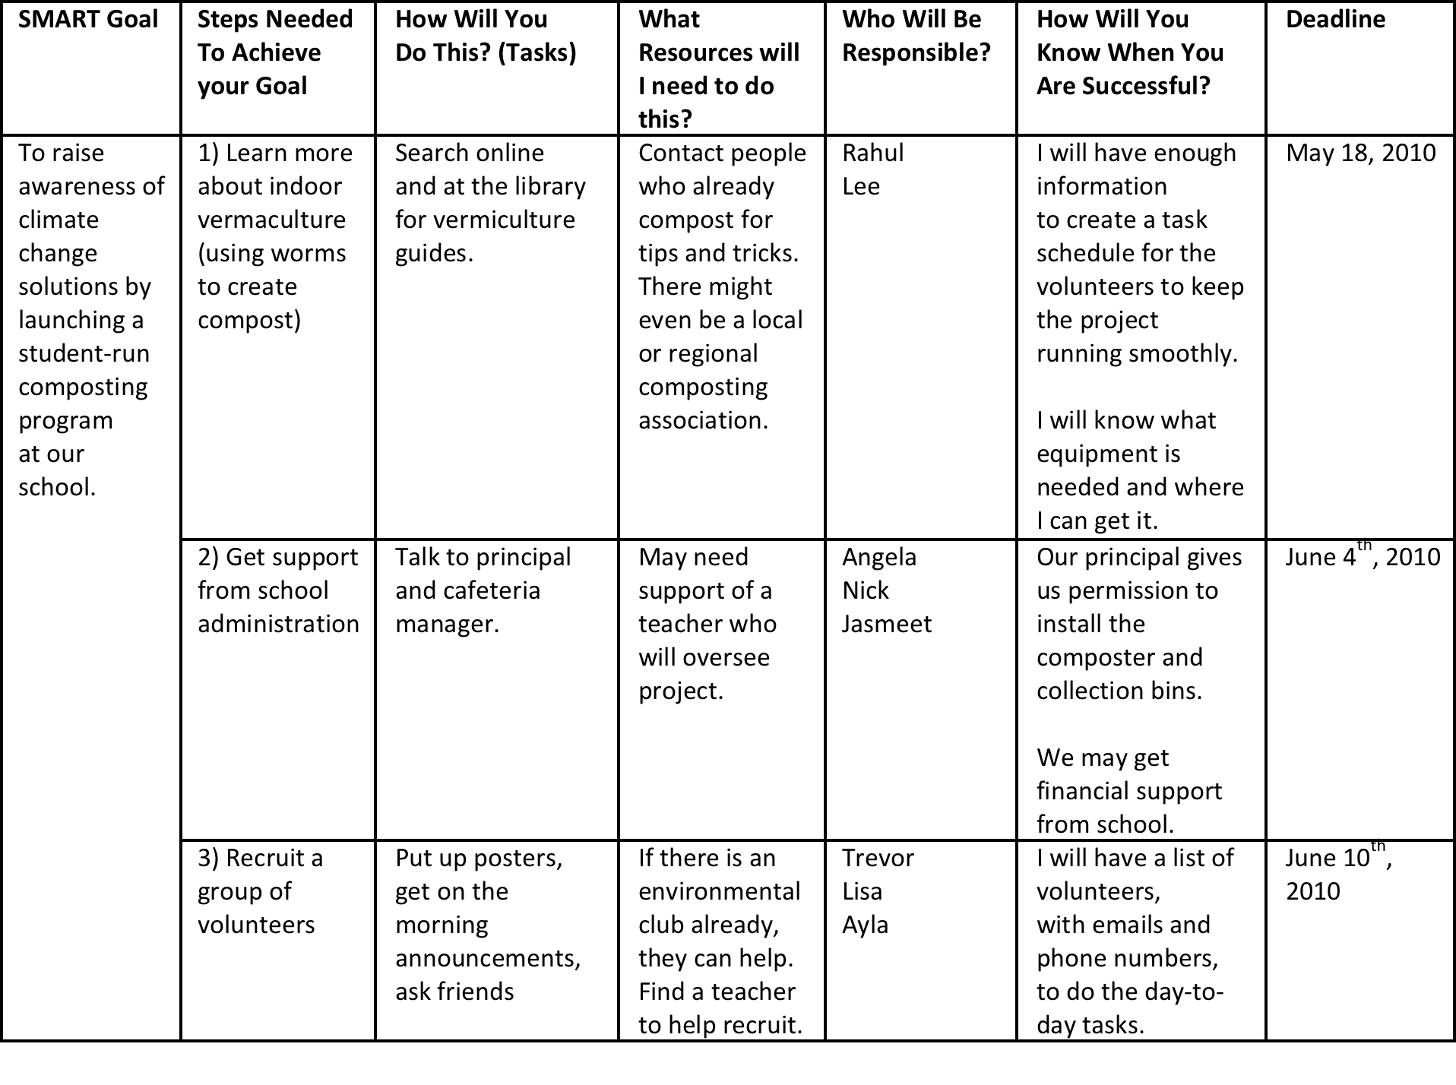

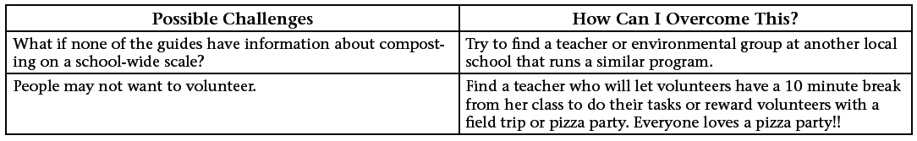
SMART Goal | Steps Needed To Achieve your Goal | How Will You  Do This? (Tasks) | What Resources will I need to do this? | Who Will Be Responsible? | How Will You Know When You Are Successful? | Deadline
1.)Raise awareness about the role of Palm Oil in deforestation. | We will find out about Palm Oil and deforestation.  We will inform Our school students, our school council, our canteen committee, the local community,  other local schools, other schools, the community –  Rotary clubs Lion’s Club, Companies that use palm oil, supermarkets and our government.  These following supermarkets- Coles, safeway,Aldi, Cosco, Bi lo, IGA, | These following ways_ Environmental Science classes,  School newsletters, school radio and T.V, Superclubs Plus,Intranet, Ultranet,  Kids teaching Kids Conference in Albury, Kids teaching Kids Conference at Silverton,  Local newspapers, community T.V and radio stations  letters to supermarkets  informing them about palm oil and deforestation | Internet access  Computers, school radio studio, T.V studio  Access sample letters from the palm Oil Action Group internet site | Silverton students from grades 5/6.  Deforestaction team and grade 5/6 students  As above | Students will be able to talk confidently about the issues with family friends, students and teachers.  Students will be able to develop  And deliver workshops on the issue of deforestation at the Kid teaching kids conference in August.  Receive a written response from supermarkets and food companies. | - Friday 4th June  June 7th- July 7th  August 20th  July- August  July 12-23rd
2.)Push for “Truth in labelling” legislation. | - Write letters to Local member of parliament asking him/her to support the “Truth In Labelling” legislation when it’s time to vote on it.  - Visit our local Member of parliament to inform him/her about palm Oil and deforestation and asking him/her to support the “Truth in labelling” legislation when it’s time to vote on it.  - Organise a petition to give people an opportunity to show their support for the “Truth in labelling” legislation.  4.Send petition to the government/ companies and supermarkets. | - Practice writing letters to M.P’s informing him about palm oil and deforestation.  - Send letters to M.P , request meeting.  - Call M.P’s office to make a meeting time  3.) Prepare and provide information to M.P on the issue.  Make a request in writing outlining what we are asking him to do.  4.) Look at petitions that other palm oil action groups are using. Design and print our own petitions if theirs aren’t suitable.  5.) Place petitions at supermarkets, libraries, Vet’s, RSPCA, the zoo, doctors, local businesses, sports clubs, parents workplaces, Taking It Global deforestaction site, Sustainable Schools Network site.  Send the petition to the companies /supermarkets and government. | Computer internet access  Telephone  Telephone  As above  Transport, parents cooperation. |  | Receive a response from M.P confirming his support.  M.P will vote for Truth in labelling bill to be introduced.  We will get a good response from the general public they will sign the petition.  We will get written responses from companies/supermarkets stating that they will be switching to sustainable Palm oil. | July 12-23
3.)Raise money to buy parts of endangered rainforests to protect from Palm Oil plantation development. |  | - Get as many students to “Take the Palm Oil Challenge”  - Send out information to parents and get parent’s permission.  - Get school council permission.  - Set a date for challenge.  - Give out permission forms  Students pledge to not eat or use any products containing palm oil or vegetable oil (possibly palm oil) for a set period of time eg 24 -48 hours.( yet to be decided) Students then get people to sponsor their effort by donating money.  - We would advertise the event at school assembly, at other network schools, school newsletter, taking it Global deforestaction site, Sustainable Schools website,Deforestaction schools websites, Superclubs plus, parents workplaces Shine magazine, community T.V and radio stations, local newspapers.  - The money raised will be given to a NGO working on saving rainforests at risk from Palm oil plantation companies. |  |  | We will have at least 50 people from our school to take the palm oil challenge.  We will raise $1000. | August 20th
Possible Challenges | How Can I Overcome This?
No response from M.P | Get parents involved- get them to write about the issue and request an interview,  Contact local papers.

