STEP 2: Create your DeforestACTION Plan!

Now that you have created your SMART goals, it is time to create a deforestACTION plan! The purpose of an action plan is to create connection between the SMART goals you have created, and the steps that need to take to achieve your SMART goals.

In your project team:

- Think about the steps you will need to take in order to make your SMART goal a reality!
- Think about any challenges that may arise – what will you do you make sure you can overcome them? Being prepared for challenges is a great way to ensure that your plan will be a success!

The example below highlights an action plan of a student-run composting program to highlight climate change. Use the chart provided on the following page to create your own DeforestACTION plan.

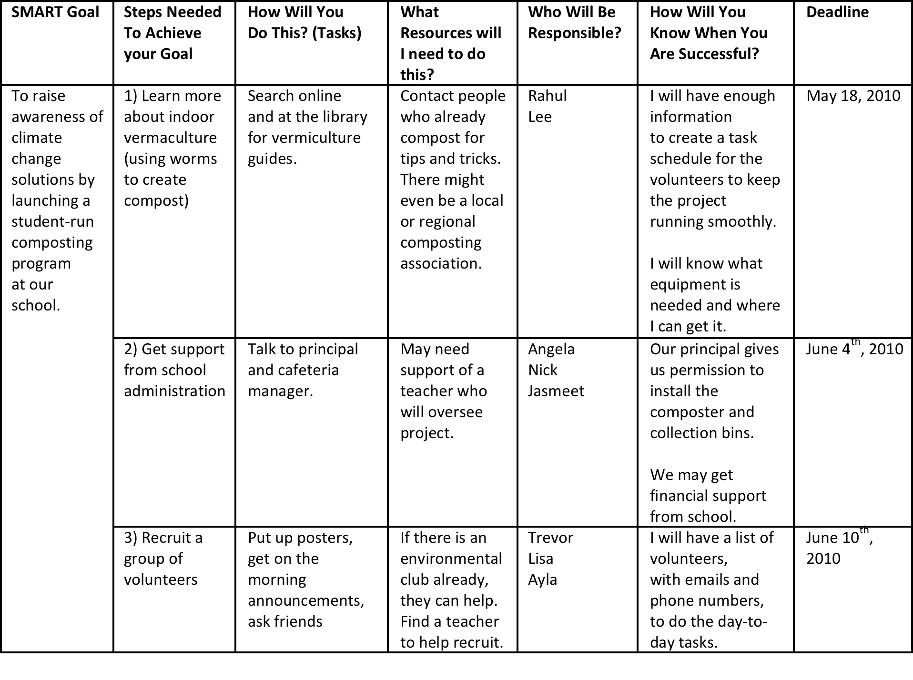

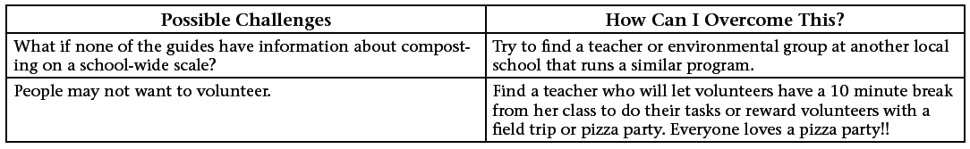
SMART Goal | Steps Needed To Achieve your Goal | How Will You  Do This? (Tasks) | What Resources will I need to do this? | Who Will Be Responsible? | How Will You Know When You Are Successful? | Deadline
To raise at least $2000 in funds and raise awareness of deforestation by promoting food which does not use palm oil. | Organize various fundraising activities to raise $2000 in funds.  Examples: Carnival, Bake Sale, Car Wash | We will get a team of students who will be assigned to organizing and facilitating a specific fund-raising event. The money collected will be donated to companies which are researching and trying to solve deforestation. | - Students  - Materials for a fundraising activity  - Sponsors | - Halyn  - Eri  - Yuri  - Amruta  - Angel | When we have raised at least $2000 in funds and successfully donated it to the companies researching and trying to solve deforestation. | Tuesday 31st August
 | Distribute pamphlets and flyers to the students of our school and design a website to highlight the problems of deforestation and offer easy ways to help save the planet. | We will ask for the Computer Club and the Interprise and Entrepreneurship Club’s help in designing and distributing the pamphlets and flyers, as well as designing the website. | - Paper  - Computers  - Printers | - Halyn  - Eri  - Yuri  - Computer Club  - I & E Club | When all the students in our school have received the flyers and pamphlets and when the website has received at least 1000 hits. | Tuesday 31st August
 | Research into which foods do not contain palm oil. | We will research online for foods which do not contain palm oil, but taste similar to foods which do. | - Computers | - Amruta  - Angel | When we have successfully discovered at least five foods which do not contain palm oil. | Wednesday 30th June
 | Organize a sale of these foods in our school canteen. | We will buy or cook these foods and sell them in our school canteen to promote palm-oil-free foods. | - Students  - Palm-Oil-Free foods | - Halyn  - Eri  - Yuri  - Amruta  - Angel  - Home Ec Department | When we have sold the palm-oil-free foods to the students of our school and raised at least $100 in funds. | Tuesday 31st August

Possible Challenges | How Can I Overcome This?
The students of our school may be unwilling to donate funds to help the companies trying to battle deforestation. | We will interest the students with various fundraising activities such as carnivals and bake sales, so they will be further interested into donating.
The students may not know much about deforestation and may be bored easily by simple information given to them. | We will make their learning experience fun and enjoyable, by including games in the website to check how much they have learned.
Palm-oil-free foods may be expensive to buy for sale. | We will either search for cheaper brands or cook the palm-oil-free food ourselves.

