STEP 2: Create your DeforestACTION Plan!

Now that you have created your SMART goals, it is time to create a deforestACTION plan! The purpose of an action plan is to create connection between the SMART goals you have created, and the steps that need to take to achieve your SMART goals.

In your project team:

- Think about the steps you will need to take in order to make your SMART goal a reality!
- Think about any challenges that may arise – what will you do you make sure you can overcome them? Being prepared for challenges is a great way to ensure that your plan will be a success!

The example below highlights an action plan of a student-run composting program to highlight climate change. Use the chart provided on the following page to create your own DeforestACTION plan.

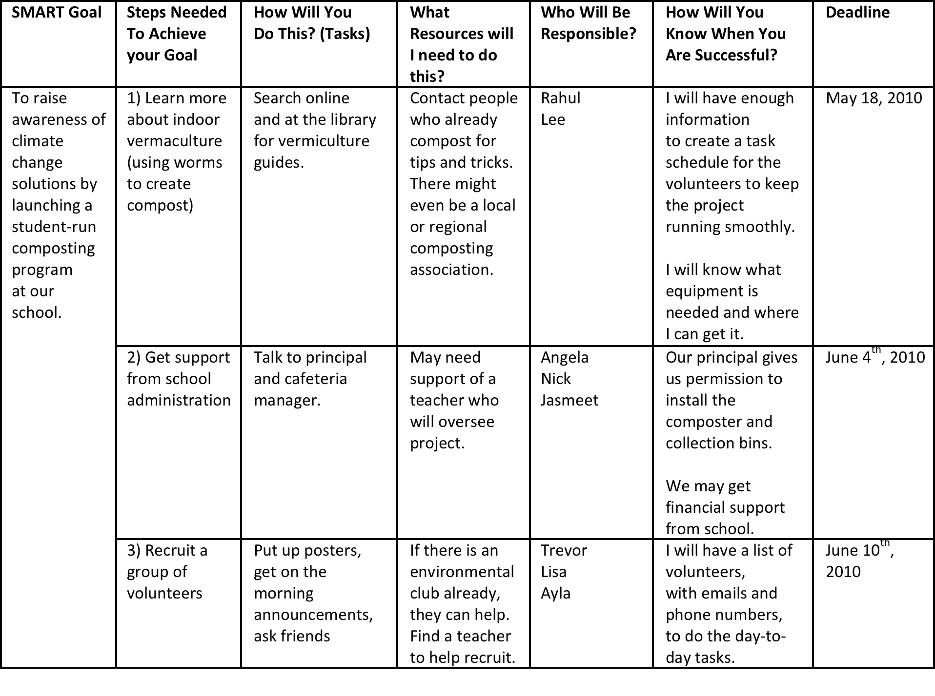

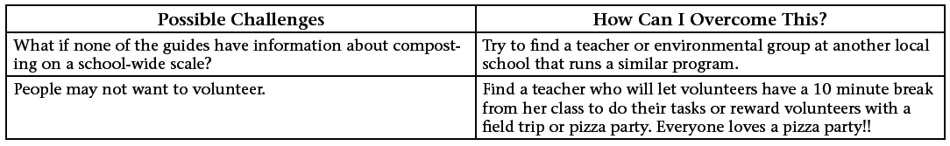
SMART Goal | Steps Needed To Achieve your Goal | How Will You  Do This? (Tasks) | What Resources will I need to do this? | Who Will Be Responsible? | How Will You Know When You Are Successful? | Deadline
To raise awareness of products we have at school and at home that contain palm oil and develop a list of environmentally friendly snack foods | Investigate what is so bad about palm oil. | Get a team of students to research on the internet and report back to us. | Netbook  Internet  Time  Students | Amal (Leader)  Varia  Caitlin  Amal | When they understand what they have researched.  When they have reported back to us. | Friday 4th June
 | Investigate products in our canteen that have palm oil | Ask the canteen manger if we can take a look at the products we have in our canteen. | Clipboard  Recording sheet  Writing materials  Netbook | Adem (Leader)  Ana  Enes  Nese | When we have the completed list. | Friday 4th June
 | Give students’ parents letters about investigating products that they use for their children’s lunches. | Write a letter to the parents of the students about the task and give them a sheet to fill out about products that they have at home that have palm oil. | Paper  Photocopier  Netbook/Laptop  Printer | Sarena (Leader)  Samantha K.  Daniel | When we’ve handed out the forms and have them returned. | Friday 11th June
 | After we’ve got the notes put the data in a graph. | Put it in a graph. | Netbook  Data/Notes  Printer | Tasos (Leader)  Christine  Shane | When the graph is finished and printed. | Friday 18th June
 | Use lists from parents/students/research to compile list of environmentally safe snack foods | Make a postcard size poster listing environmentally friendly snack foods | Information from parents  Research  Netbook  Printer  Photocopier | Mr Evans maths group to collate data  Each grade 5/6 Grade come up with own card and we vote | When postcards are finished | Wednesday 30th June so families have it for holidays
Possible Challenges | How Can I Overcome This?

