STEP 2: Create your DeforestACTION Plan!

Now that you have created your SMART goals, it is time to create a deforestACTION plan! The purpose of an action plan is to create connection between the SMART goals you have created, and the steps that need to take to achieve your SMART goals.

In your project team:

- Think about the steps you will need to take in order to make your SMART goal a reality!
- Think about any challenges that may arise – what will you do you make sure you can overcome them? Being prepared for challenges is a great way to ensure that your plan will be a success!

The example below highlights an action plan of a student-run composting program to highlight climate change. Use the chart provided on the following page to create your own DeforestACTION plan.

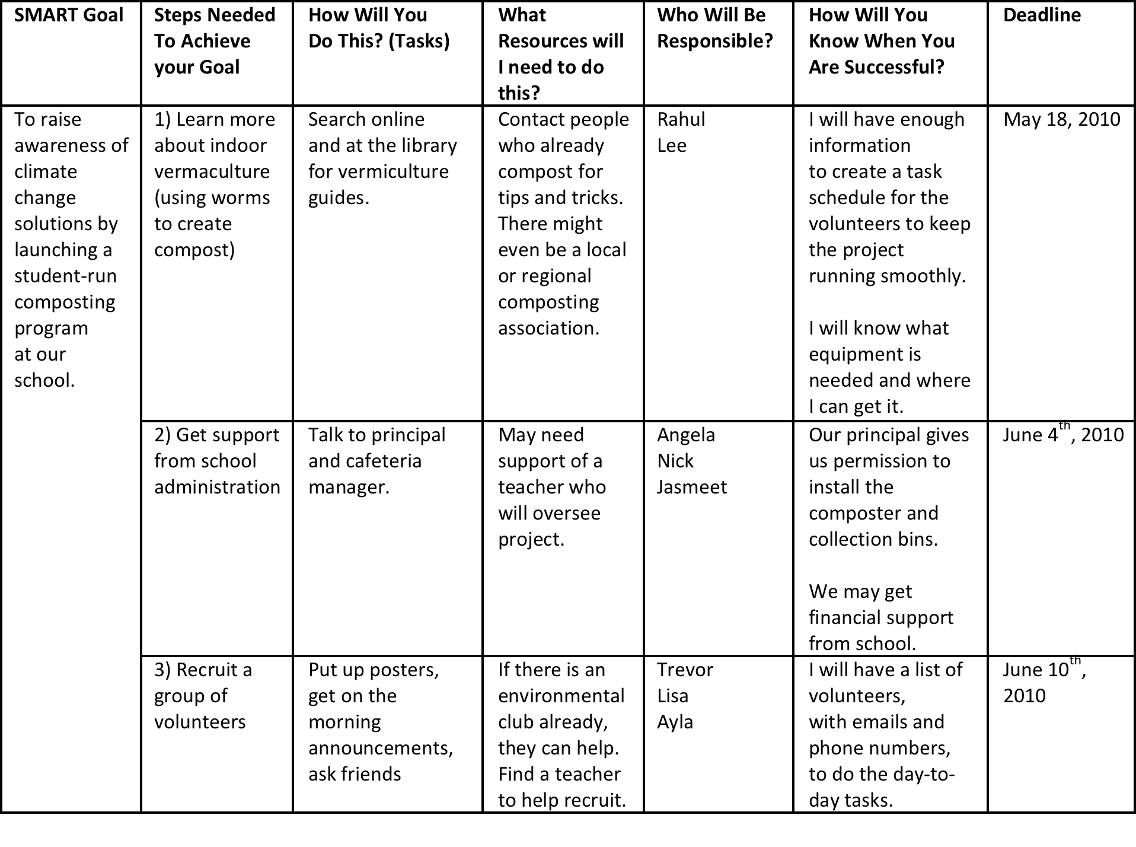

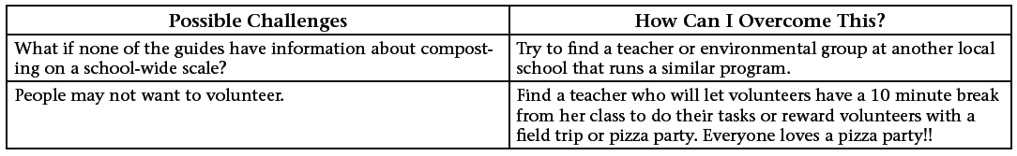
SMART Goal | Steps Needed To Achieve your Goal | How Will You  Do This? (Tasks) | What Resources will I need to do this? | Who Will Be Responsible? | How Will You Know When You Are Successful? | Deadline
Possible Challenges | How Can I Overcome This?

