Orangathon©

Dear Mrs Kerr,

We would like to have, on Friday the 10th of December, a day where the first three periods are dedicated to the awareness of DeforestACTION through the Orangathon©.

First period will be for the year 8’s. Second for the year 9’s and for the third period, year 10’s.

During these periods, the year groups will be separated into three groups and rotated through the activities. The first group will go to a performance; the second will go to some fun, physical activities. The last rotation will be an educational activity.

The aim of these activities is to raise awareness of what is happening to the orang-utans in Asia.

Sincerely,
Year 8 Society and Environment class

Period | Activity | Presenters | Time
1 | All Students from year 8 come to PAC and we briefly tell them what’s going on. After that, there will be a play* which will involve telling the students what’s going on in Indonesia with the palm oil and orangatangs. |  | 8:50-9:05; year 8’s arrive at PAC. Play goes for around 15-20 minutes.
1 | The students will then be separated into two organised groups and be sent off to two activities.  Group 1 goes to the oval to do some activities** and group 2 goes to S2/S3 for an internet quest***. |  | 9:10-9:25; students are sent to the separate activities.
1 | The two groups will then swap activities.  The period will end as usual and the students will go onto their next period as usual. |  | 9:30-9:45; the three groups return to the PAC for a summary on what’s happened and there’s likely to be a Q&A until end of period
2 | All Students from year 9 come to PAC and we briefly tell them what’s going on. After that, there will be a play which will involve telling the students what’s going on in Indonesia with the palm oil and orangatangs. |  | 9:52-10:07; year 9’s arrive at PAC. Play goes for around 15-20 minutes.
2 | The students will then be separated into two organised groups and be sent off to two activities.  Group 1 goes to the oval to do some activities** and group 2 goes to S2/S3 for an internet quest***. |  | 10:12-10:27; students are sent to the separate activities.
2 | The two groups will then swap activities.  The period will end as usual and the students will go onto their next period as usual. |  | 10:32-10:47 the three groups return to the PAC for a summary on what’s happened and there’s likely to be a Q&A until end of period
Recess
3 | All Students from year 10 come to PAC and we briefly tell them what’s going on. After that, there will be a play which will involve telling the students what’s going on in Indonesia with the palm oil and orangatangs. |  | 11:24-11:39; year 10’s arrive at PAC. Play goes for around 15-20 minutes.
3 | The students will then be separated into two organised groups and be sent off to two activities.  Group 1 goes to the oval to do some activities** and group 2 goes to S2/S3 for an internet quest***. |  | 11:44-11:59; students are sent to the separate activities.
3 | The two groups will then swap activities.  The period will end as usual and the students will go onto their next period as usual. |  | 12:14-12:29 the three groups return to the PAC for a summary on what’s happened and there’s likely to be a Q&A until end of period
4-5 | Back to normal

*Performance

The performance will be a play that starts with a demo of what’s going on in Indonesia, then the scene will stop and Jaclyn will come on stage and ask “what’s wrong with this” indicating the scene, frozen in time.

**Activities

The activities will be a puzzle game with the puzzle pieces hidden in the volleyball sand then the student will need to find them.

***Internet Quest

The students will be given an internet quest to fill out and hand in, and then they’ll be marked.

Further information attached.

PUZZLE SEARCH

YOU HAVE TO FIND YOUR PUZZLE PIECES IN THE SAND PIT BEFORE THE OTHER TEAM DOES.

RULES:
- NO INTERFERRING WITH THE OTHER TEAMS WHEN SEARCHING FOR THEIR PIECES.
- NO HIDING THE OTHER TEAMS PIECES.
- YOU ONLY HAVE A CERTAIN TIME TO FIND YOUR PUZZLE PIECES.
- YOU CAN ONLY GO WHEN YOUR TEAM MATE TAGS YOUR HAND.
- ONLY ONE PERSON MAY SEARCH FROM EACH TEAM AT A TIME

- ONCE THE PUZZLE IS FINISHED MAKE SURE YOU SIT DOWN AND YELL! FINISHED!

PRIZES:
YOU GET A FREDDO FROG AND THE CHANCE TO BRAG ABOUT WINNING TO YOUR SCHOOL MATES.

EQUIPMENT:
- GIANT PUZZLE PIECES (Miss Sheedy)
- FREDDO FROGS (WE CAN GET)
- BRUSHES FOR DUSTING OF FEET. BYO
- SUNSCREEN. BYO

Deforestaction!

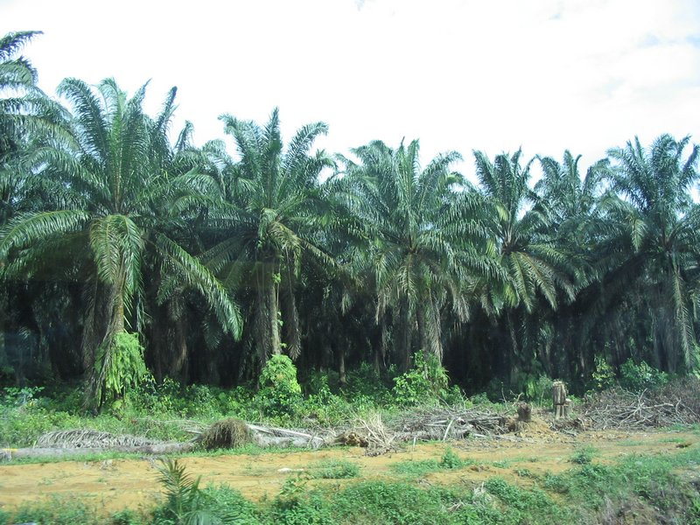

- Where is palm oil found?

- Where abouts is deforestation mainly found?

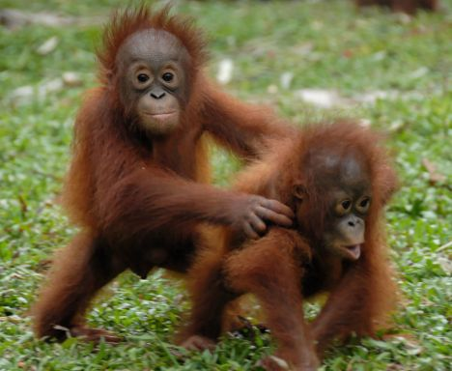
- What is deforestation doing to our orang-utans?

- Why are they cutting down trees?

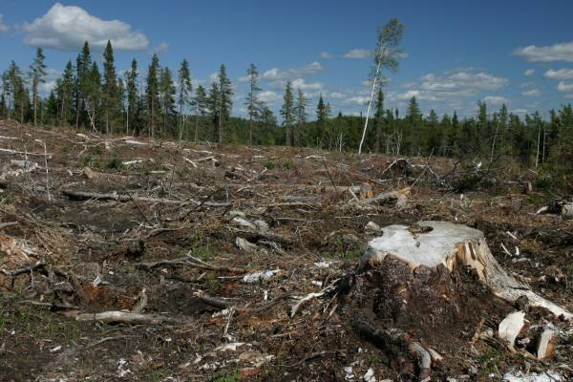

- Why should we stop deforestation?

- How long do orang-utans live for?

- What family do orang-utans belong to?

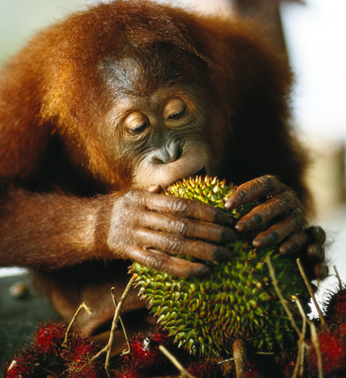

- What do orang-utans eat?

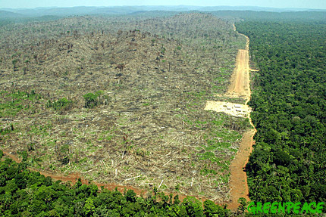

- What is the average size of an orang-utan?

- How many trees are cut down each year?

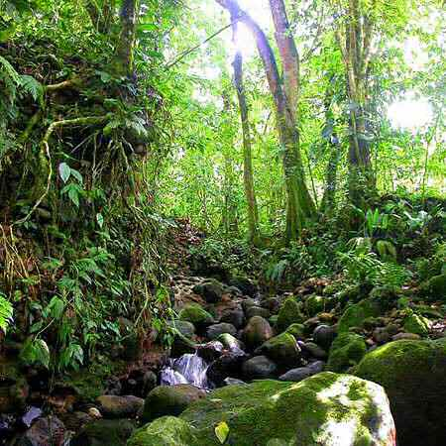

- What climate are rainforests found in?

- What animals are in danger?

Answers

- in palm trees
- all around the world mostly
- taking their homes away from them and killing them
- to plant palm oil trees
- to help save the orang-utans
- 35 to 40 years
- the ape family
- plants, fruit, insects and small animals but are mostly herbivores
- 4 to 5 foot
- 3 billion to 6 billion trees per year
- Tropical rainforest
- Orang-utans

.

Requests:

We would like to take the year 8’s out of period 1, year 9’s out of period 2 and the year 10’s out of period 3.

We also request the PAC for the first three periods.

We would like the puzzle pieces that Miss Sheedy possesses.

We would like to have a computer lab to allow multiple students to go on the internet for the internet quiz.

Script.
Opening scene:
Matt and Josh are in a tree.
*spotlight on them, rest of the room dark*
*matt and josh improvise*
*dramatic music plays*
Indonesian men (Jess and Lilli) come running out and start to chop down the tree.
Ben hears what is happening and comes running out.
Ben: Stop! Stop what you’re doing!
Jess: One person won’t stop us.
Ben: Who said I was alone?
All the saviours (Shani, Ally, Karissa, Luke, Jordon, Blake and Cody.)
Everyone gets rowdy and loud. The saviours are chanting with their signs and Jess and Lilli are fighting up.
*over voice yells “pause!”*
Jaclyn comes out and explains the situation.
Jaclyn: Our planet Earth is under threat. Sounds very horrible, right? But yes it is true. It is all because of deforestation. Can anyone tell me what’s wrong with this scene?
Jaydon is in the audience and answers the question slowly making his way onto the stage.
We explore into the paused scene and say numerous amounts of facts about deforestation.
Jaclyn and Jaydon go off scene
*scene resumes*
The tree gets chopped down and Matt and Josh are left on the ground, sulking.
*light goes dark, change of scene*
Lilli and Jess walk across the stage with a sign saying “meanwhile”
Scene shows children in a class room, on facebook when Josh (Ms Ellis)
All the students quickly close and back onto the deforestACTION site.
Josh: “ What are you kids doing?”
Kids: ‘ Just on deforestACTION miss”
Ally: ‘definitely not on facebook miss’ *smiles sweetly.*
*everyone gives Ally the ‘death stare”*
*scene pause*
Jaclyn and Jaydon walk out and explain what deforestACTION is.
*scene resumes*
Ashleigh: “Miss! Miss Ellis! There is some news about the rainforest in Indonesia! Two baby orang-utans have lost their homes!
Jamie: Miss, how can we help?
Josh:’ What are we suppose to do?’
Ally:’ Well miss, we are currently raising money to help save them. Even a small donation makes a difference.”
*lights go dark, scene changes back to a rainforestion.”
Matt and Josh are still sitting on the floor, sulking.
Whole crew comes out, and says in unison:
‘Everyone can make a difference, even you”
Scene ends.

