Malaria
Human malaria was most likely originated in Africa. The first evidence of malaria parasites was found in mosquitoes preserved in a tree. Malaria may have been a human pathogen for the entire history of the species. Humans may have originally caught Plasmodium falciparum (cause of malaria) from gorillas. About 10,000 years ago malaria started having a major impact on human survival which coincides with the start of agriculture

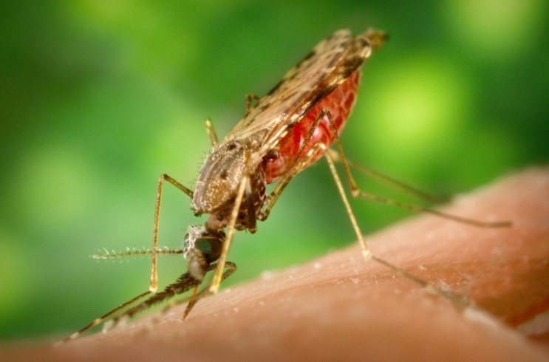

Malaria is a disease caused by the female anopheles mosquito. The male anopheles mosquitoes don’t cause malaria because they don’t bite humans and drink blood. They live on plant juices. The females carry parasites (called plasmodium) that get into our blood and infect the red blood cells. There are four types of malaria – Vivax, malariae, ovale; the most serious type is falciparum .It mainly occurs in high humidity, moisture and high temperatures like in Africa and the Pacific.

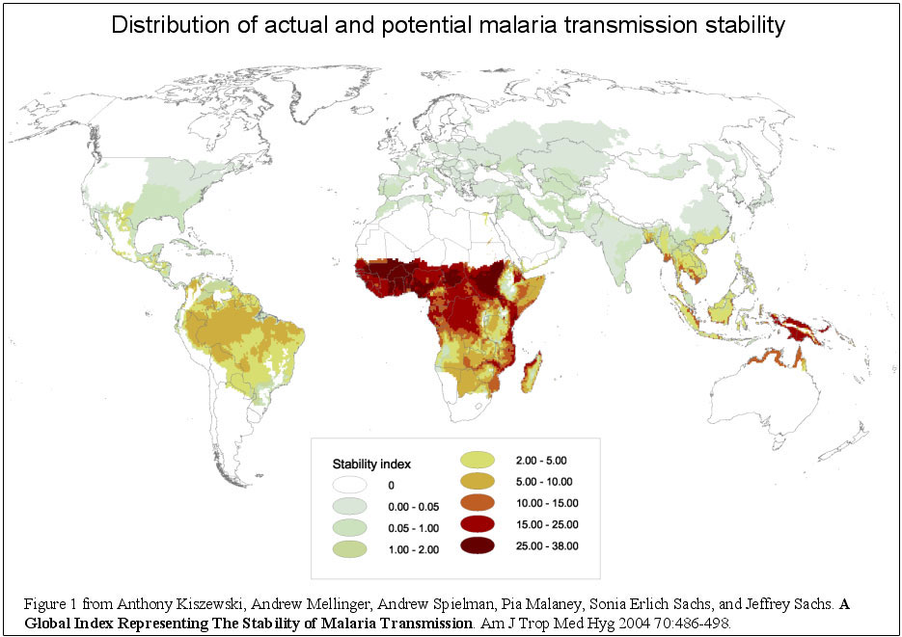

Malaria causes about 225 million illnesses and kills approximately 780 000 people every year. Approximately half of the world's population is at risk of malaria. Most malaria cases occur in Africa. However, Asia, Latin America, and to a lesser extent the Middle East and parts of Europe are also affected. In 2010, 99 countries and territories had ongoing malaria transmission.

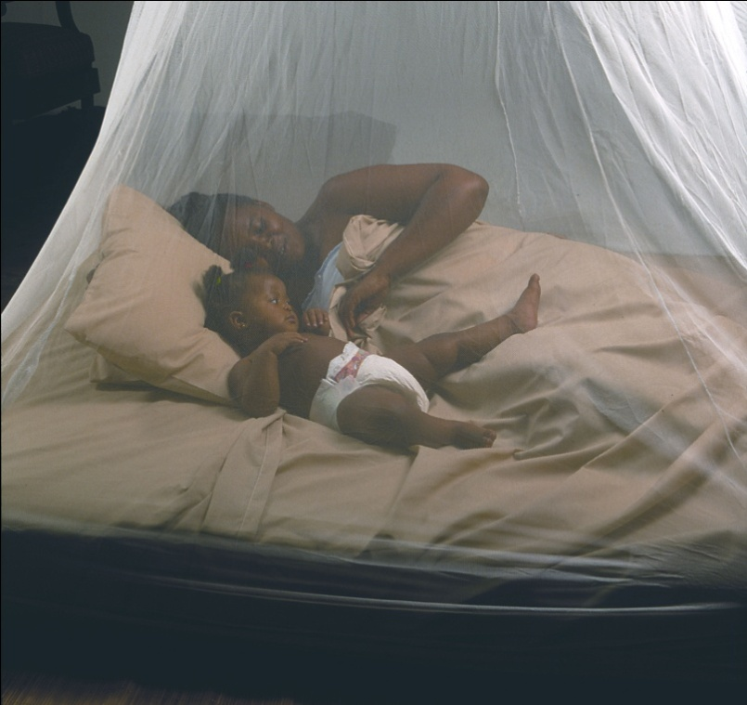


To prevent malaria it is suggested that you sleep with a mosquito net, use a mosquito coil and insect repellent when you go outside. This prevents the mosquito from affecting you. You shouldn’t let any water be stagnant for too long because then the mosquitoes may breed.

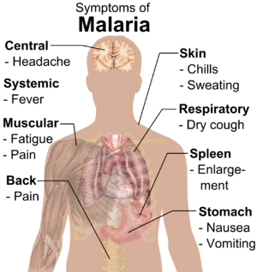
Symptoms of malaria include;
- bad fever
- headache
- vomiting,
- Other flu-like symptoms
The symptoms start to show about 9 days after the mosquito bite.

Malaria can be treated if the infected person visits a health center of a hospital early enough. The three main medicines used for the prevention of malaria – doxycyline, malarone, and mefloquine. Early diagnosis and treatment of malaria reduces it spreading and prevents deaths. The best available treatment, particularly for P. falciparum malaria, is artemisinin-based combination therapy (ACT).

Ruth Fa, Makira Cornish and Litia Baleilevuka

