WHERE IT OCCURS?
Leprosy occurs all over the world, however most sufferers are to be found in the populous countries of south east Asia, Africa and South America - there are 3.5 million sufferers in India.
SIGNS AND SYMPTOMS:
The early signs can vary, depending on the patient’s resistance to the disease. People with LEPROMATOUS leprosy usually develop and skin rash or nodules while TUBERCULOID leprosy might first show itself as an area of numbness or "PINS AND NEEDLES!" People with darker skin sometimes have patches which are paler in color than their normal skin. There is no one “first sign” of leprosy and careful examination by a doctor of skin smears under a microscope are necessary for correct diagnosis.
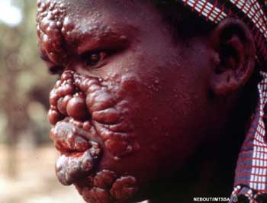
SYMPTOMS INCLUDE:
- Skin lesions that are lighter than your normal skin color
  - Lesions have decreased sensation to touch, heat, or pain
  - Lesions do not heal after several weeks to months
- Muscle weakness

- Numbness or lack of feeling in the hands, arms, feet, and legs
PREVENTION:
Prevention consists of avoiding close physical contact with untreated people. People on long-term medication become noninfectious (they do not transmit the organism that causes the disease). In Fiji all lepers were put on a single island where a colony was formed and nuns and priests were sent to assist in the aiding of the patients – most of them did this knowing that they would not come back.
TREATMENT:
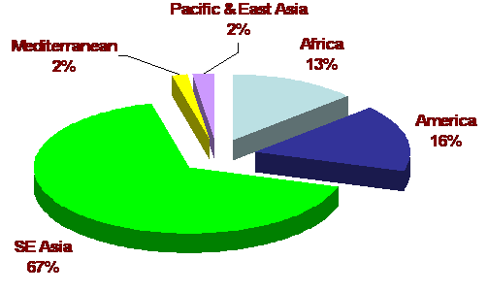
A number of different antibiotics (including dapsone, rifampin, clofazamine, fluoroquinolones, macrolides, and minocycline) are used to kill the bacteria that cause the disease. More than one antibiotic is often given together. Aspirin, prednisone, or thalidomide is used to control inflammation.
HOW IS LEPROSY CAUGHT?
Scientifically speaking, it is almost impossible to prove how the leprosy germ gets from one person to another, but people with lepromatous leproy expel large numbers of germs from their nose and mouth. It may be that they get into the body the same way. Other theories are that blood-sucking insects and close skin to skin contact could be ways of transmitting the disease. The discharge from ulcers on the hands and feet very rarely contains live leprosy germs.
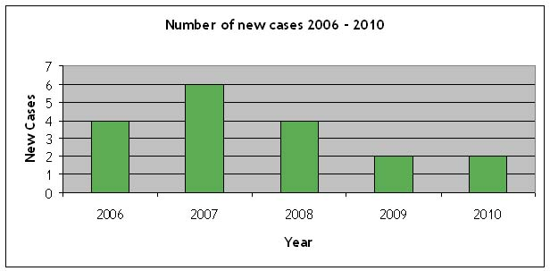

Statistics for Fiji!

WHY DO PATIENTS WITH LEPROSY BECOME CRIPPLED?

Not all patients become crippled. Many become healed without any treatment at all and others who have been diagnosed and treated in the early stages of the disease suffer no deformity. The main cause of deformity in leprosy patients is nerve damage. This occurs because the leprosy germs have a peculiar liking for nerve tissue and multiply freely between nerve fibres. When the leprosy germs die or are killed by the medicines, the resulting inflammation compresses and destroy these delicate fibres with more or less complete loss of function. So feeling is lost and muscles are paralysed. The end result is ulceration and deformity.

FACTS ABOUT LEPROSY:
- In every ten thousand people in Fiji there is one leper case.
- South East Asia is home to most of the Leprosy cases in the world (67%)
- Up to 20 percent of cases occur before the age of 10. In children, the disease occurs equally in males and females. In adults, it is twice as common in males as females.
- A clawed hand or drop foot can be restored with surgery and physiotherapy. Surgery can also restore eyelid movement, so a person can blink. However, surgery cannot bring feeling back to the numb areas of the body.
- Leprosy can stay in the body for up to 20 years without showing symptoms.
- Around 150 cases in the U.S. alone are found each year and there are approximately 250000 cases each year worldwide.
- The disease has mistakenly been associated with biblical leprosy, which scholars believe was actually a variety of skin diseases categorized under the term leprosy.
REFERENCES:
- Pub Med Health, Viewed on 8th October 2012, <http://www.ncbi.nlm.nih.gov/pubmedhealth/PMH0002323/ >
- Web Spawner, viewed on the 8th of October 2012, <http://www.webspawner.com/users/prashan/ >
- Fiji Times, viewed on the 8th October 2012, <http://www.fijitimes.com/story.aspx?id=108328 >
- Med TV, viewed on the 15th of October 2012 <http://diseases.emedtv.com/diseases/leprosy-facts.html >
- ILEP, viewed on the 15th of October 2012 < http://www.ilep.org.uk/ilep-co-ordination/leprosy-around-the-world/oceania/fiji/>

BY: Georgia Naidu and Ernest Gibson.

