Elephantiasis

Elephantiasis (filariasis) is a type of infectious diseases, caused by filarial worms which are transmitted by various species of mosquitoes. After being bitten mosquitoes, parasites (larvae) will spread into the lymphatic system where the disease develops. This disease is chronic and if not treated, can cause permanent disability in the form of enlargement of the legs, arms and genitals of both women and men. In most cases the disease is not fatal.

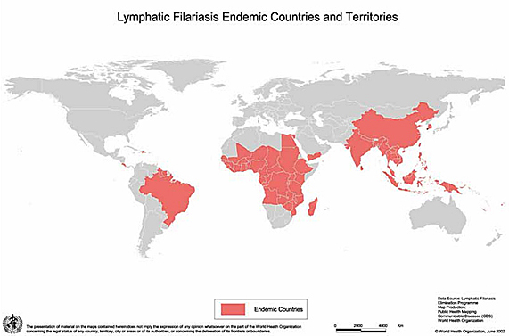
Elephantiasis disease is most commonly found in tropical regions. According to information from WHO, the countries h\that have the most developed cases of the disease is South Asia (India and Bangladesh), Africa, the Pacific, Americas, Thailand and Indonesia (Southeast Asia).

Signs and Symptoms of elephantiasis

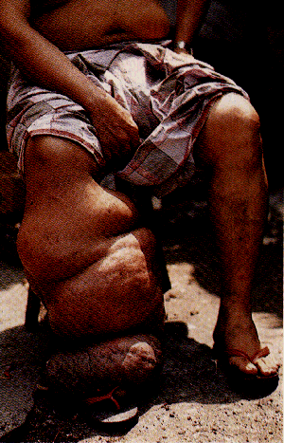
A person infected with the disease elephantiasis usually obtains it in childhood years and after a long period of time, (many years) the disease begins to develop.

The symptoms that are possible to occur include:

* Fever over and over again for 3-5 days.

* Swollen lymph nodes (no injuries) groin area, armpits (lymphadenitis), which looks red, hot and sore

* Filarial abscess due to frequent suffering from swollen lymph nodes, may rupture and ooze pus and blood

* Enlargement of the legs, arms, breasts, testicles that look a little flushed and hot (early lymphodema)

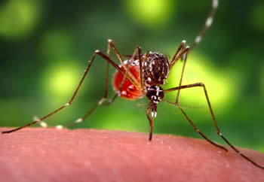
Prevention of Lymphatic Filariasis
One of the main ways to prevent elephantiasis, would be to avoid getting bitten by mosquitoes. You can do this by applying mosquito repellent regularly when going out and installing mosquito coils if you are outside.
You can also prevent this disease by keeping the environment you live in hygienic. There is a tablet called Albendazole which is used as a preventive measure against elephantiasis.
According to medical experts the worldwide efforts to eliminate lymphatic filariasis are on track to potentially be successful by 2020. About 6.6 million children have been prevented from being infected, with another estimated 9.5 million in whom the progress of the disease has been stopped.

Treatment

Lymphatic filariasis is a disease which takes a period of time to be removed completely. The treatment is very long, and results aren’t always successful. Even if the disease is not active anymore because it has being treated over a period of time there will always be a bit of the disease left in the human body and the little bit can reactivate.
Treatment is different depending in which country around the world it has affected; different regions have different types of elephantitis.
In most cases, the disease is treated with antibiotic medication.
Surgery can also be a way of eliminating the illness, by removing the infected area the rest of the skin around isn’t infected anymore, but surgery proves ineffective when it is elephantitis of the limbs.
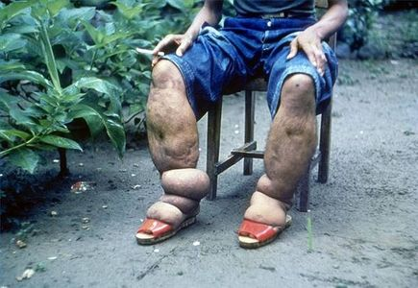

Development of the Disease
Elephantitis is a real problem in poor countries and developing countries as the illness can be caused by dirt and and unhealthy environments, shoes should be worn at all time to prevent infections and then the illness of elephantitis as it often progresses from infections. Although the illness is quite common, it is far less of a problem now then it was before, cures are being made and it is possible that the illness will be gone soon.
The illness itself is slowly decreasing as more and more people start having healthy diets and clean environments. The medication created to help prevent and stop the illness is now circulating around the world and is being used more and more, unfortunately not everyone can afford to buy the medication and this is one of the reasons the illness hasn’t already disappeared, hopefully by 2020 the illness will be gone due to treatment becoming more accessible.

