CHLAMYDIA
Chlamydia is a common sexually transmitted disease (STD) caused by the bacterium, Chlamydia trachomatis, which can damage a woman's reproductive organs. Chlamydia can happen to any sexually active person. Most often, Chlamydia occurs to adolescents and young adults, aged (15-24) who have new or multiple sex partners or choose to avoid using a condom or barrier. In 2010, 1,307,893 chlamydial infections were reported to CDC from the 50 states of America and the District of Columbia.
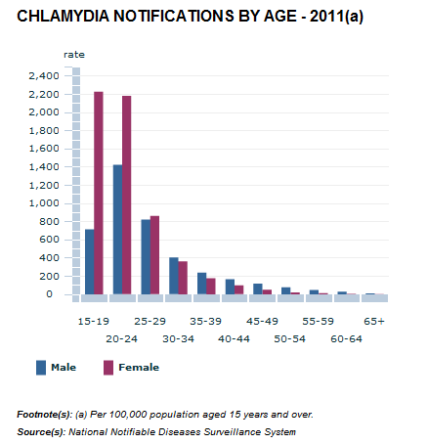
In 2011, chlamydia was the most frequently reported notified condition in Australia, with 79,833 new notifications for people aged 15 years 435 cases per 100,000 population. This rate has more than tripled over the past decade, increasing from 130 notifications per 100,000 in 2001. Chlamydia is found in 20-40% of teens having sex outside of marriage. Up to 40% of all girls between the ages of 14 and 19 are infected. This is the highest Chlamydia infection rate of any age group.

SIGNS AND SYMPTOMS
Symptoms of Chlamydia are usually mild or absent. If untreated serious complications that cause irreversible damage, including infertility, can occur “silently” before a woman ever recognizes a problem. Many at risk individuals don not go for Chlamydia testing. When I say “silently” it means the patient will not know until the symptoms are visible.
For women, Chlamydia symptoms are abnormal vaginal discharge or a burning sensation when urinating. If the infection spreads from the cervix to the fallopian tubes, some women would still not feel or see any signs or symptom; others have lower abdominal pains, pain in the lower back, nausea, fever, pain during intercourse, or bleeding between menstrual periods. Chlamydia can cause discharge from the genitals of an infected man and a burning sensation when urinating. They may also feel a burning or itching near the opening of the penis.
The most definite way to avoid transmission of any sexually transmitted disease, including chlamydia, is to:
- Abstain from sex
- Know the symptoms so that you could immediately avoid it.
- Be faithful
- Ask your partner if they have any sort of STI before having sexual intercourse, and if so, immediately treat it
- Regularly Get Tested
- Use Condoms
Chlamydia can actually be treated easily by antibiotics. One dose of azithromycin or a week of doxycycline (twice daily) is the most commonly used treatments. HIV-positives with chlamydia should receive the same treatment as those who are HIV negative. People with chlamydia should abstain from sexual intercourse for at least 7 days. Commonly, in women, whose sex partners have not been properly treated have a high risk of being re-infected. Multiple infections can cause serious reproduction health problems like infertility.

Fiji Tops Chlamydia List
Samantha Rina
Tuesday, September 14, 2010
According to an article in the Fiji Times in 2010, Chlamydia topped the list of Chlamydia in the Pacific. This was announced at an STI workshop in Suva. In the article it mentions that according to an STI adviser with the Secretariat of the Pacific Community, in 2008 26.8% of pregnant woman in Fiji suffered from Chlamydia. This percentage doesn’t seem as much does it, although when we compared it to other graphs and charts of around the world it came out to be a big difference. This places Fiji as having the highest prevalence of Chlamydia in the Pacific. Surprisingly, the rates in the Pacific are even higher in Asia and Africa. The rates of treatments over here are really pricy.
According to this article, it clearly states that Fiji-of 2010-has top the Chlamydia rates in the Pacific. Dr. Jimmie Rogers from Fiji says that one in every three or four young people aged 15-24 may be infected with Chlamydia in Fiji. She says that the reason why Chlamydia happens more to women than men is that this world still suffers from inequality in some areas. Especially in the pacific where some also face cultural taboos and limited access to health care.
Chlamydia was first recognized in the early 1940’s. It wasn’t spoken of much. In 1960’s the invention of the pill changed the idea of premarital sex, practically overnight! People started to have sex more because the worry of getting pregnant wasn’t there anymore. Unlike any other contraception, the pill was both reliable and controlled by women themselves; they didn’t need any sort of consent from their partner. Within 5 years of the pill being on the market, 6 million American women were on the pill. Although the pill prevents pregnancies it does not prevent STI’s at all and this knowledge has not been taken into account by many women over the world and that is why ever since mid 1900’s, the STI and teen sex has risen consequently thus Chlamydia rates are continuously rising as well.

REFERNCES
- http://chlamydia.emedtv.com/chlamydia/chlamydia-prevention.html
- http://www.abs.gov.au/AUSSTATS/abs@.nsf/Lookup/4102.0Main+Features10Jun+2012
- http://www.fijitimes.com/
- http://www.scoop.co.nz/stories/WO1003/S00302.htm/

Hanah, Shikha and Binal ☺

