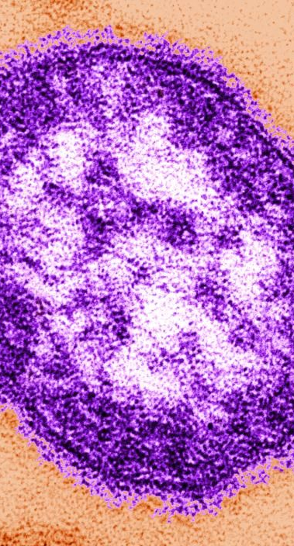
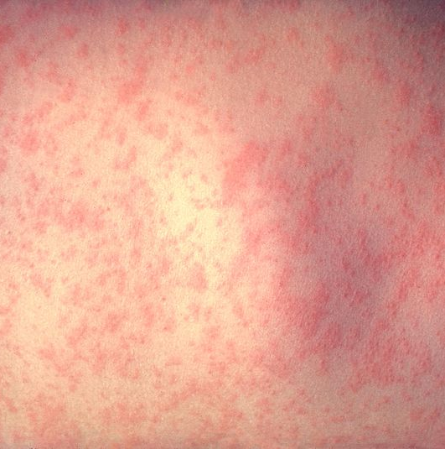
History:

Originated in 165 AD in Europe

First known as “The Antonine Plague,”
and the “Plague of Galen.”

Side affects:
Diarrhea
Pneumonia
Acute encephalitis
Ulceration (corneal, leading to scarring)
Causes:
Jumped from cows to humans, then mutated. Hasn’t changed since.
Caused by the measles virus, much like HIV
Symptoms & Detection
Fevers uop to 104*F
Cough, cold, conjunctivitis
Anorexia
Rashes
Measles
Death & Prevention
Measles is the leading cause of death among children under the age of 5. In 2010 there were 139,300 measles deaths globally. .3% mortality rate in the US

Prevention:
Stay away from sick people, it is transferred via contact with tissues that are infected, coughing, and sneezing.

Treatments:
There is no cure for measles; doctors can only treat the symptoms & side affects

